|  |  |
| --- | --- |
| *school-learn-study-hat-graduate-512.png* | ***Study*** |

**Exercise 1:**

* Learn “element element” selector from [this short tutorial](https://www.w3schools.com/cssref/sel_element_element.asp)
* You may want to look at a better organized demo [here](https://codepen.io/huynq-work/pen/ooPwvN)
* Write a page to demonstrate this selector

**Exercise 2:**

* Learn how to create a horizontal, center navigation bar from [this tutorial](https://csswizardry.com/2011/01/create-a-centred-horizontal-navigation/)
* Tips: You might want to read the code first, if you can understand it, you’re good to go, if not, read the explanation, or ask your instructor and/or Quy to explain it to you

**Exercise 3:**

Learn how to add padding to an element **WITHOUT** increasing its size

|  |  |
| --- | --- |
|  |  |

Hint: box-sizing

**Exercise 3:**

Open Atom and install “Color picker” plugins (here is [the guide](https://flight-manual.atom.io/using-atom/sections/atom-packages/) in case you forgot how to)

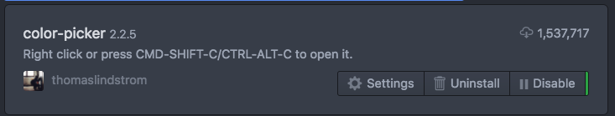

**Inside your css file**, right click, then click on menu item “Color Picker”:

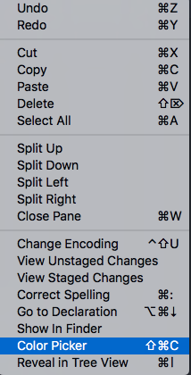

Learn how to use it to get hex AND rgb color as value in your css. Write a demo about this

|  |  |
| --- | --- |
| *6iporAnbT.jpg* | ***Serious exercises*** |

**Exercise 2:**

Implement this page header:

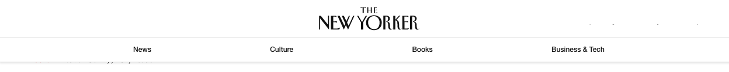

**Exercise 3:**

Implement the following block:

